Little Leaders’ Links
Issue #28 April 2022
info@littleleaderskck.com
913-299-1821

Issue #130 March 2018
info@kslittlelearners.com
913-254-1818

2022 Planned Activities

April 2022
Activity | Date
Week of the Young Child  Easter Parties  3 p.m.  Easter Egg Hunt  (In the morning)  Happy Bear  (Circles and Rectangles)  Family Fun Night | Monday, April 4th through Friday, April 8th  Thursday, April 11th  Friday, April 12th  Tuesday, April 19th  9:15 & 9:45  Thursday, April 28th  6:15-7:15pm
May 2022
Activity | Date
Teacher Appreciation Week  Muffins with Mom  Pre-K Graduation  Ice Cream Man  Move Up Day  Little Leaders CLOSED for Memorial Day | Monday, May 2nd through Friday, May 6th  Friday, May 6th  7:00-8:30am  Friday, May 13th  7:00-8:00pm  TBD  Friday, May 27th 3:00  Monday, May 30th

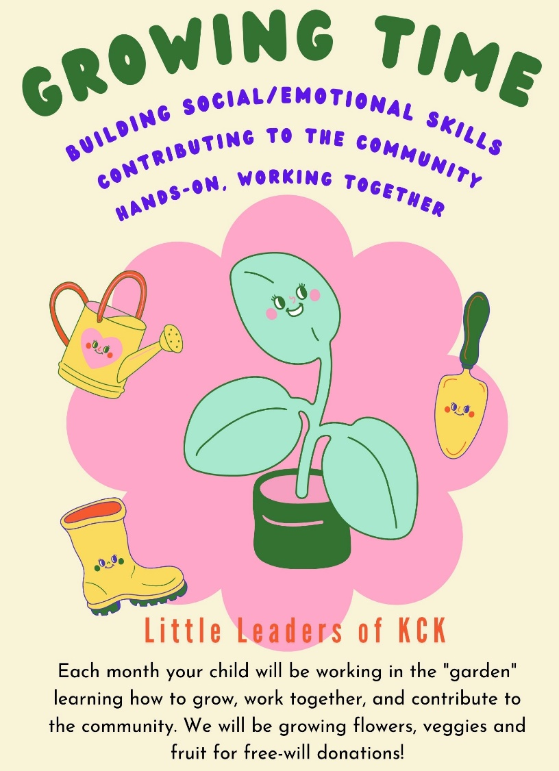
Growing Time at Little Leaders of KCK

Dear Parents, this spring and summer we will be introducing our Growing Time program! Your child will be getting the chance to be hands on in the garden outside. Toddlers will work with Ms. Lindsey once a month and Preschool and PreK twice a month. During these times Ms. Lindsey will be modeling how to work together, help our community by donating produce, and building social emotional skills with peers. In the garden beds on the playground, they will be planting vegetables, fruits, and flowers together as a class!

Our Pre-K Graduation
ceremony will be held on Friday, May 13th. It will start at 7:00pm and it will be held at the Preforming Arts Center located on the campus of KCKCC. There will be a short ceremony and presentation of diplomas. We will then have a celebration with drinks and cookies afterwards.

Thank You and Congratulations!!!
We want to share a special thank you and congratulations to our new families who started attending after a referral. The new family and the referring family each received $100!! We have more referrals to celebrate next month as well!

Thank you so much for helping others learn about Little Leaders of KCK and for trusting us with the care and education of your little leaders.
Week of the Young Child

Monday, April 4th: Rainbow Day-Wear rainbow clothes or favorite color.

Tuesday, April 5th: Sports Day- Wear your favorite sports teams’ clothes.

Wednesday, April 6th: Nighttime/Star- Wear glow in the dark/shiny clothes.

Thursday, April 7th: Dinosaur Day- Wear dinosaur clothes and have a dinosaur lunch.

Friday, April 8th: Pajama Day- PJ Day and breakfast for lunch.

